**Pharmers Academy**

**Business Description**

Pharmers Academy is a division of Pharmers Pty Ltd, a registered consulting pharmacy and training centre dedicated to enhancing the skills and knowledge of professionals in the medico-pharmaceutical field. Our mission is to empower individuals to excel by offering specialized courses in regulatory affairs and other pharmaceutical sectors, creating opportunities for career advancement.

With a commitment to continuous learning and professional growth, we provide a comprehensive educational experience that equips learners with the skills required to excel in the healthcare and pharmaceutical industries. Whether you’re looking to enter a new field or elevate your current career, Pharmers Academy is here to guide you every step of the way.

**Vision Statement**

"**Aspire to More Than the Average, Learn and Become Greater**, **Explode Your Potential**, **Choose from Over 30 Courses and Switch Sectors**"

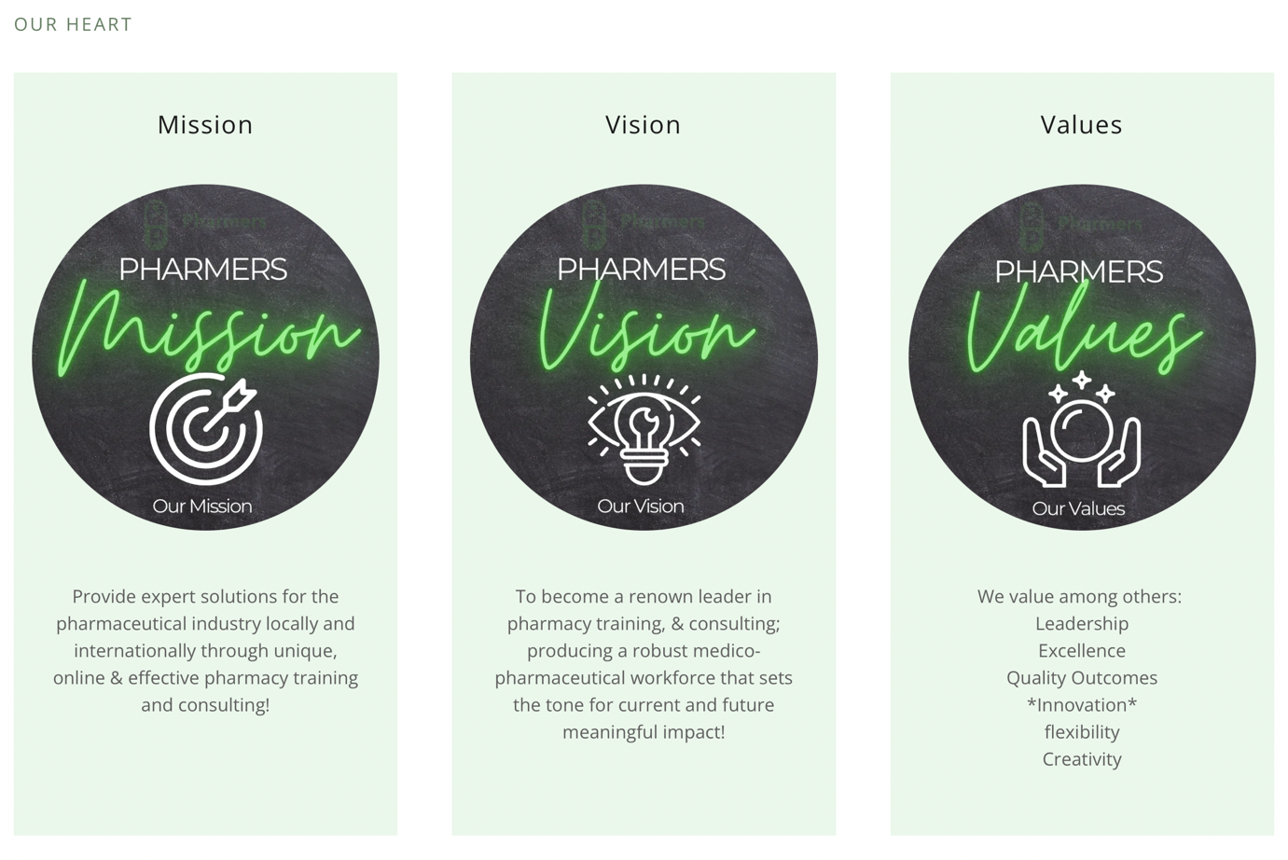

**Goals**

1. **Training Impact**  
   In 2024, we successfully trained over 200 learners, empowering them to reach new professional heights. In the coming years, we aim to increase this number and expand the diversity of learners we serve.
2. **Curriculum Growth**  
   To expand and diversify our curriculum, offering specialized and industry-relevant courses, including CPD programs, to meet the ever-changing needs of the sector.
3. **Online Learning Platform Development**  
   Enhance our online platform for seamless learning experiences, allowing students to access content, interact with peers, and track their progress easily.
4. **Global Reach**  
   Extend our educational services to international learners, providing accessible training to individuals across the globe and creating partnerships with international organizations.

**Website Features**

Pharmers Academy’s website will be designed to provide a seamless experience for prospective and current learners. Key features for the website include:

1. **Home Page**
   * A welcoming homepage that introduces Pharmers Academy and highlights our mission, values, and course offerings.
   * Sections dedicated to showcasing our courses, achievements, FAQs, contact details, testimonials and upcoming enrolment periods etc.
2. **Course Catalog** 
   * A view page displaying all available courses with a brief description and pricing for each.
   * Each course listing will include a link to an application form.
   * When a student proceeds to payment, they will be logged into the site automatically and granted access to the course content.
3. **Payment Gateway**
   * A secure, user-friendly payment system for easy course enrolment.
4. **Log-In Page for Enrolled Learners**
   * A dedicated login page different types of users to log in with personalized credentials:
     1. **Learners** will log in to access course materials, Submit assignments and quizzes as well as track their progress.
     2. **Facilitators** will log in to upload course content, grade assignments, and communicate with learners( Chat function)
     3. **NB **Administrators** will have full access to manage users, oversee course content, track payments, and generate reports.

**Please find attached Supporting Materials**

* **Brochure**: Academy course offerings and enrolment process( Application form, Pricing and short description).
* **Pharmers Academy Logo**